

|  |  |
| --- | --- |
| E-Commerce Website  Manual |  |
| A manual that will help with setting up the website as well as how to use it.  By Bryce James (18002305) |  |

**Part 1 Setup**

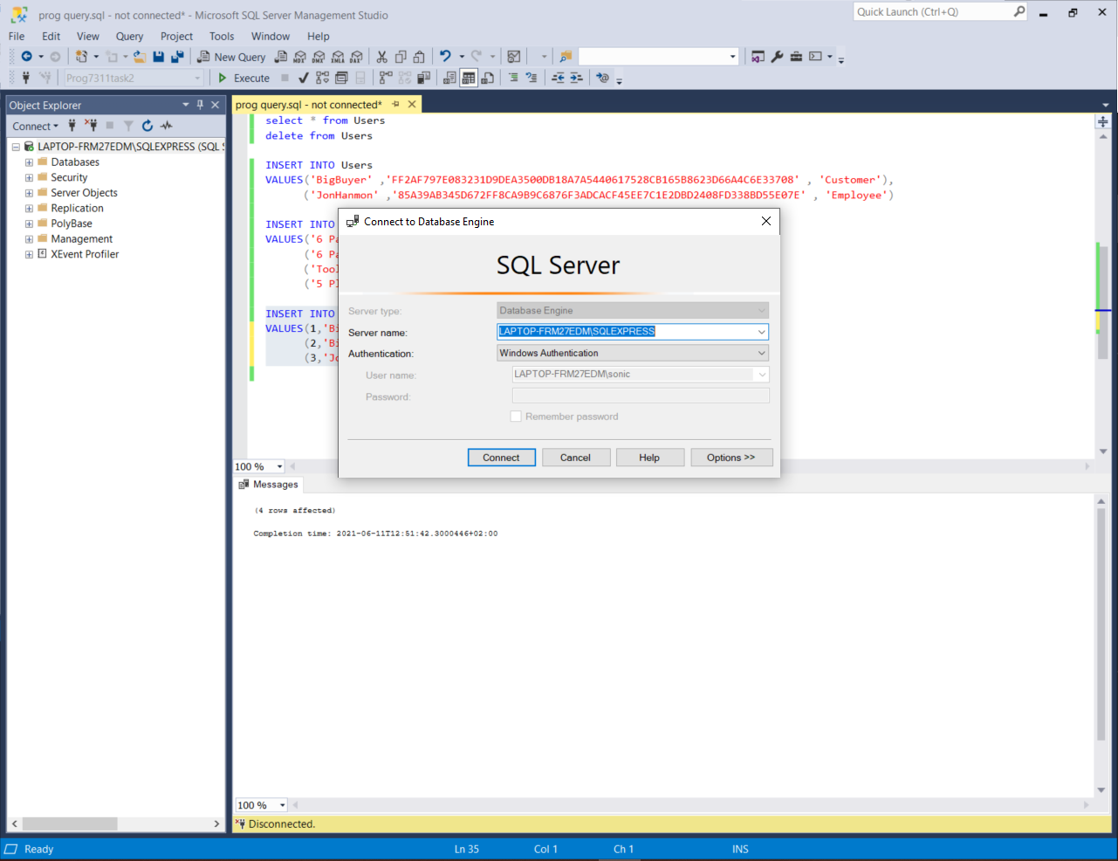Setting up the website is easy. First you will have to start up the local sql database with the sql code provided.(p.s. don’t forget to take down your server name for later use.)

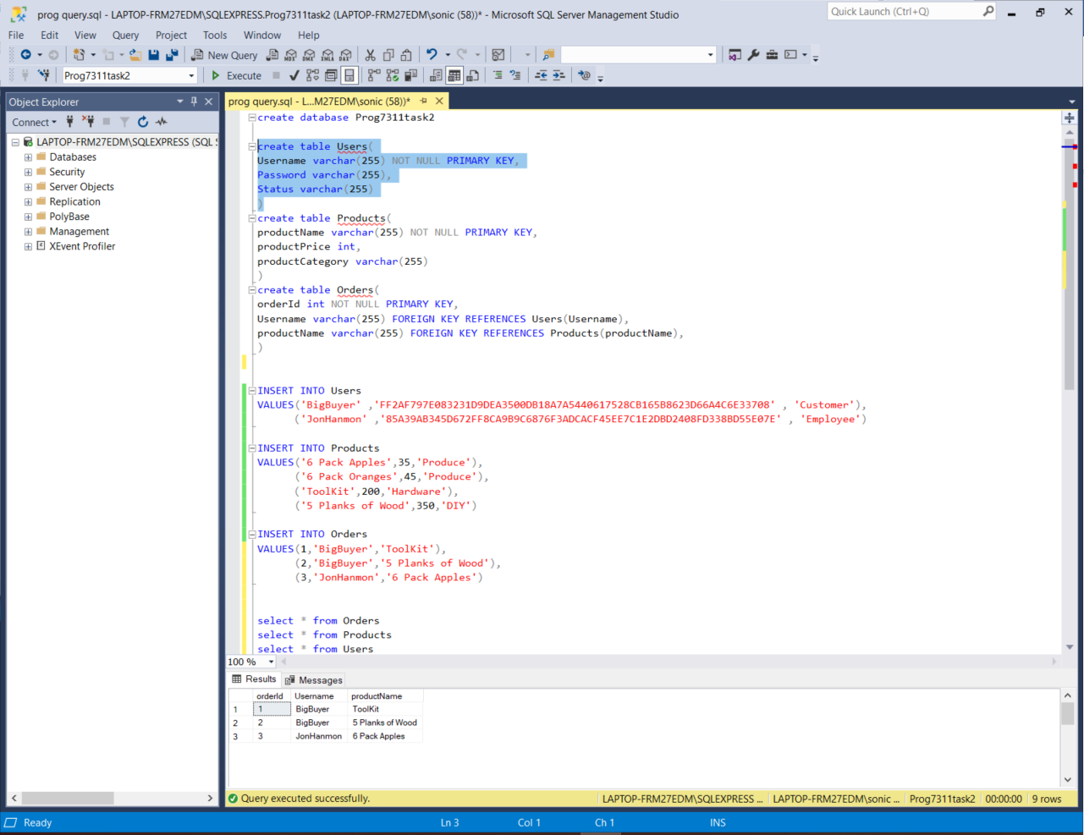After that highlight the code and run it.(**Warning**: do not run all code at the same time. Highlight and run each create and insert one at a time) (**side note** the sql database has pre hashed passwords so please read the passwords provided for they are the unhashed ones that will be compared)

Now we need to set it up in visual studio. For that we start by adding a server and then we input our server name and select the database we want, in this case ‘Prog7311task2’.

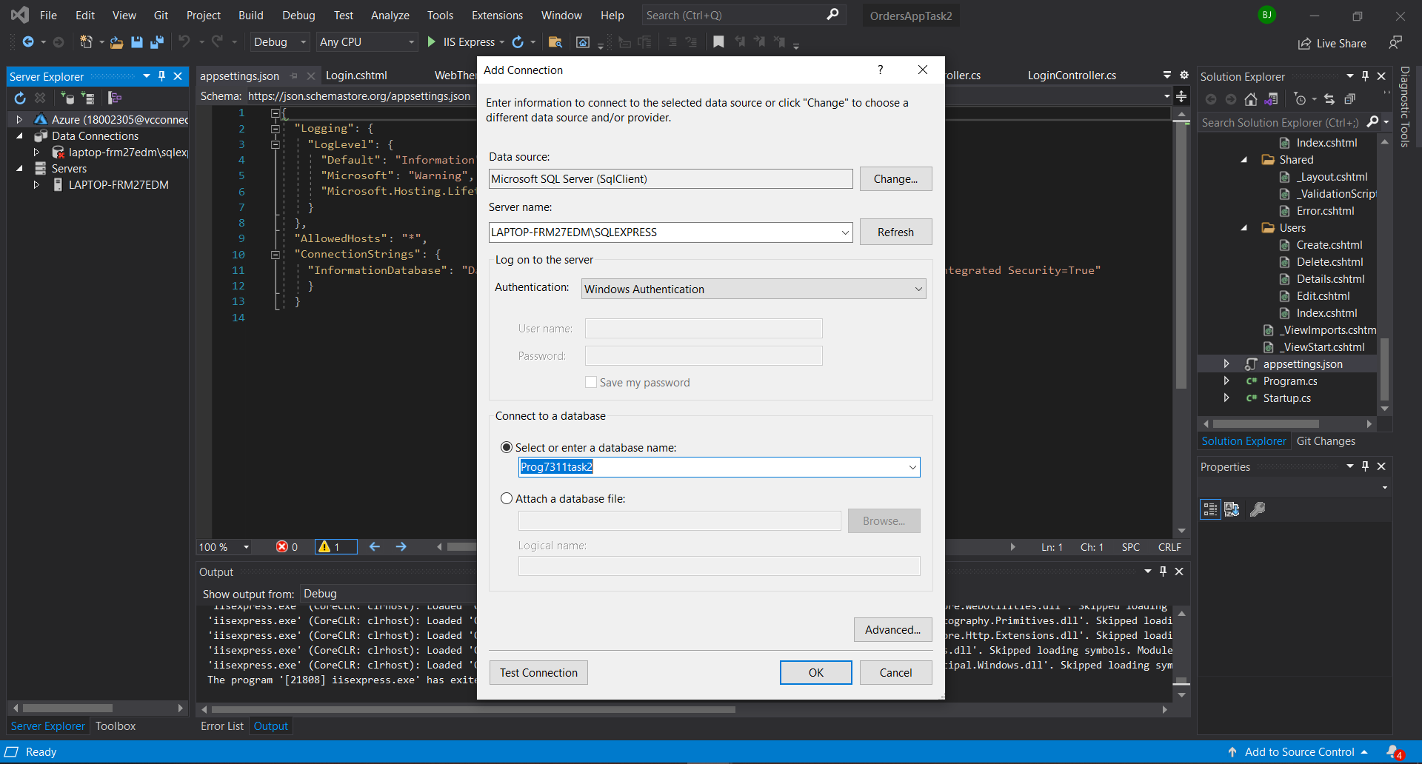

After that, the last thing we need to do is get the connection string for the database by clicking it and finding it in the properties on the bottom right hand corner

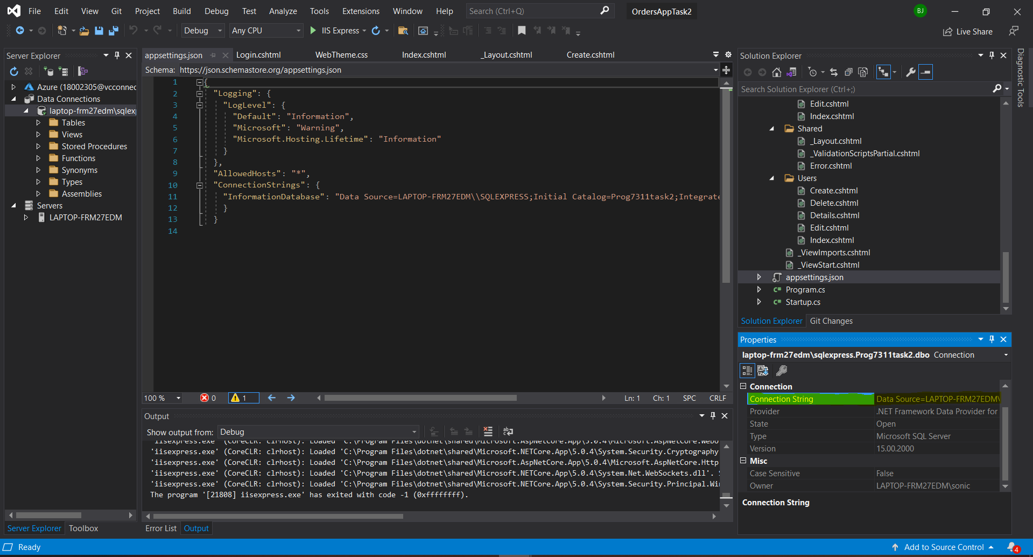

And replacing the previous connection string with the new one in the appsettings Json

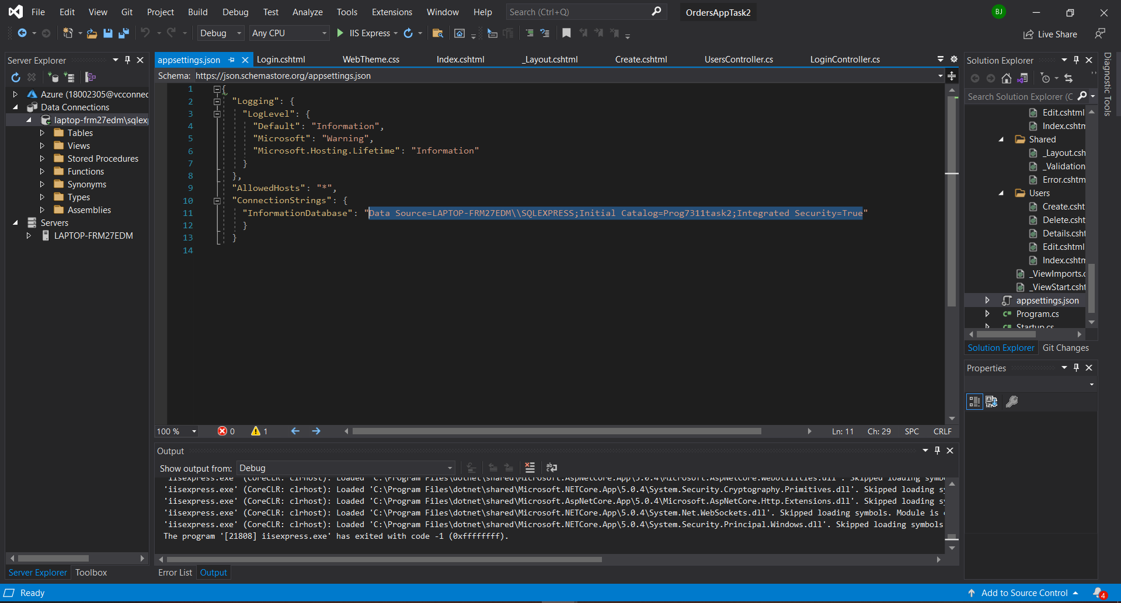

And with that the database for the website is complete and we can now move on to using it.

**Part 2 Using without login**

This website has differences based on the status of who ever logs in. we have customers and employees. If you do not login you will have very minimal access to things. The most you will be able to do is go to the products page and search for items.

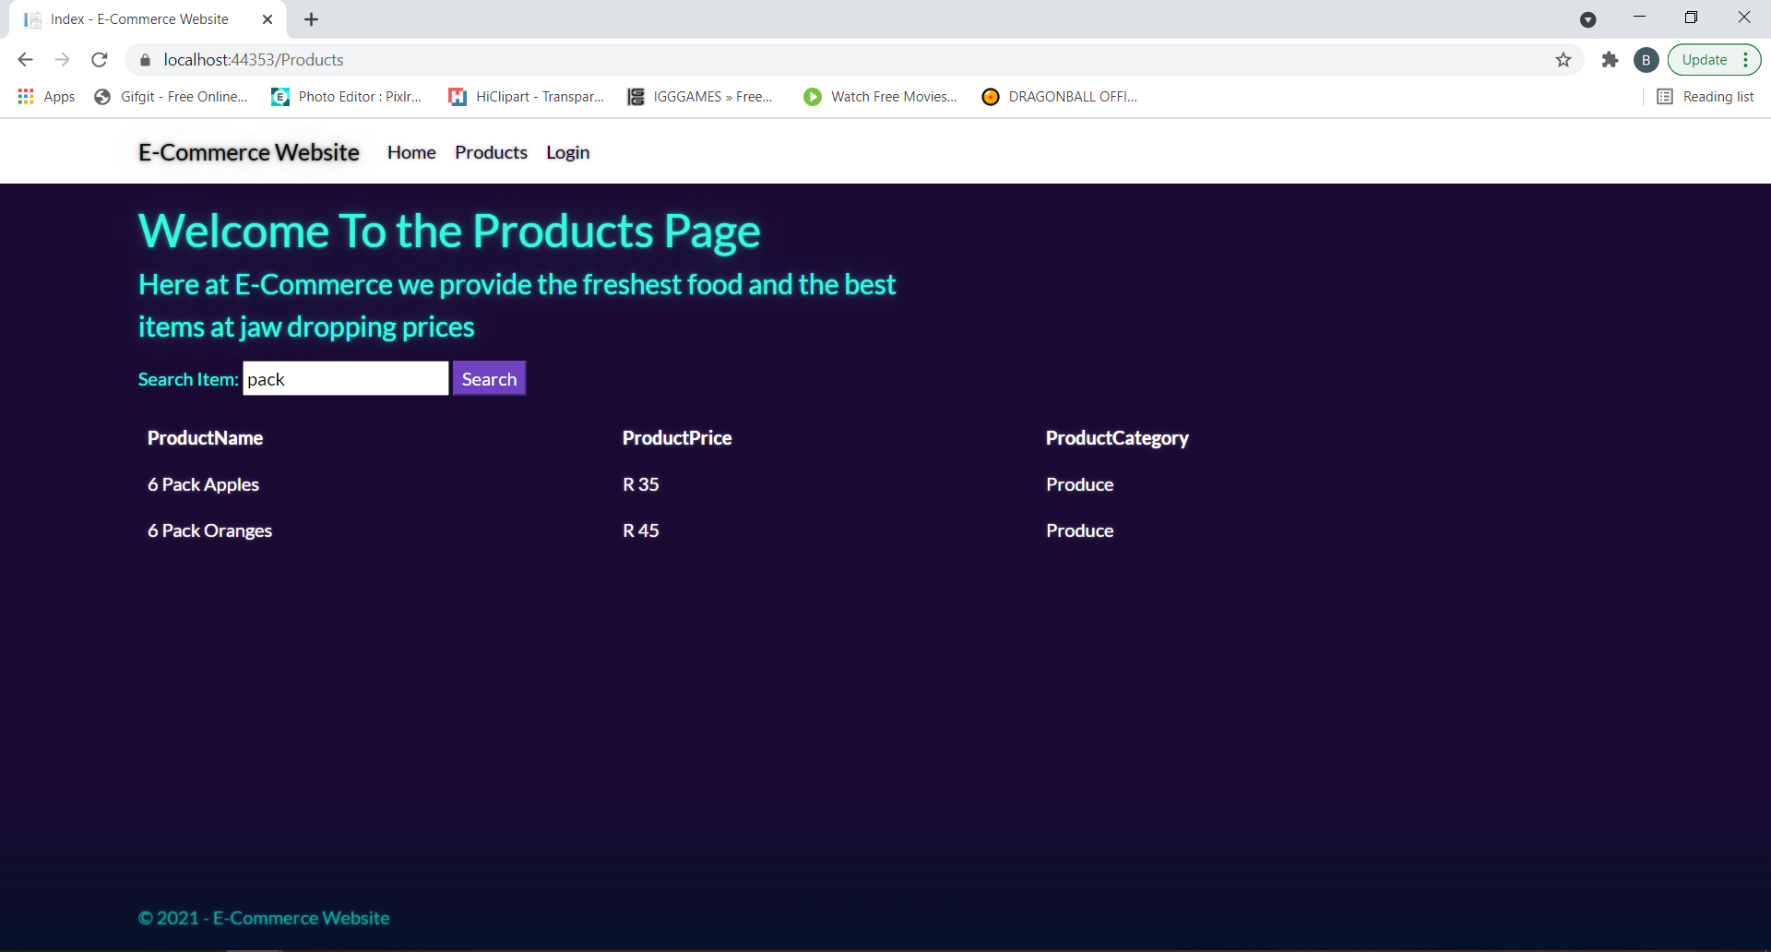

And login.

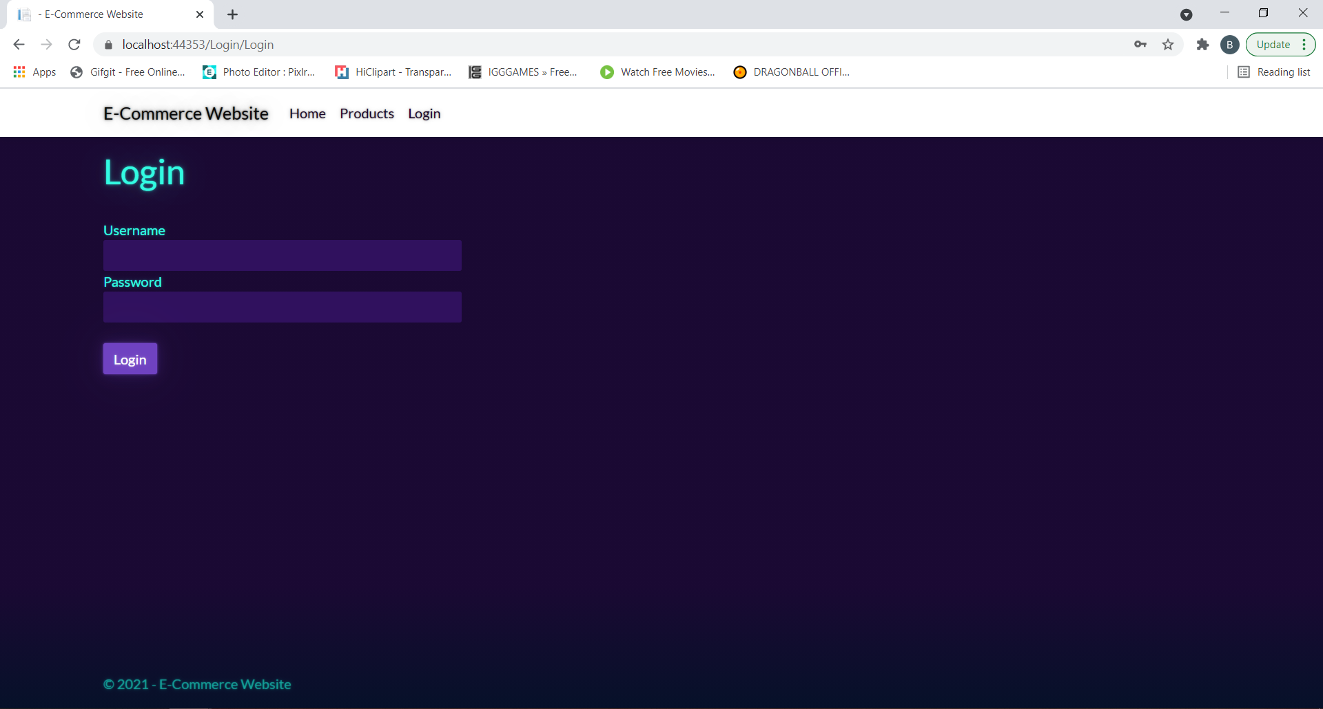

**Part 3 Using as a Customer**

For our test of a user account we have made a customer user called ‘BigBuyer’ and their password is ‘ShopDrop’. As soon as you login with the customer user the navbar will have more options made available to the customer.

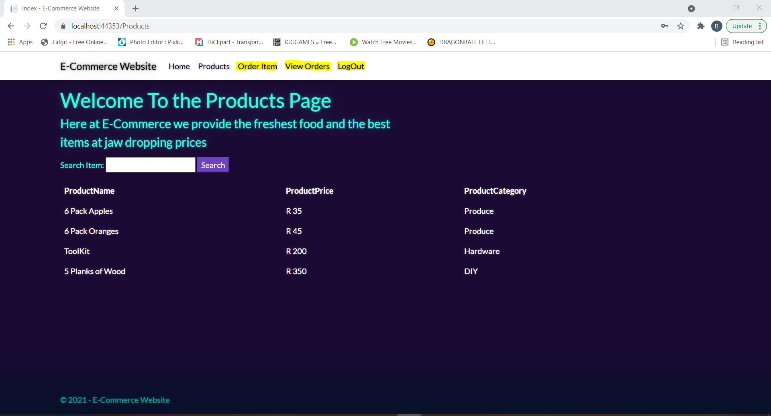

The order items tab will take a user to the order items page where they can select the item they want to buy. Once they have selected the item they would like to buy they press the purchase button and will be taken to a screen to show successful purchase has been made and their order will be logged.(picture doesn’t show but the select item is a drop down box with list of available items)

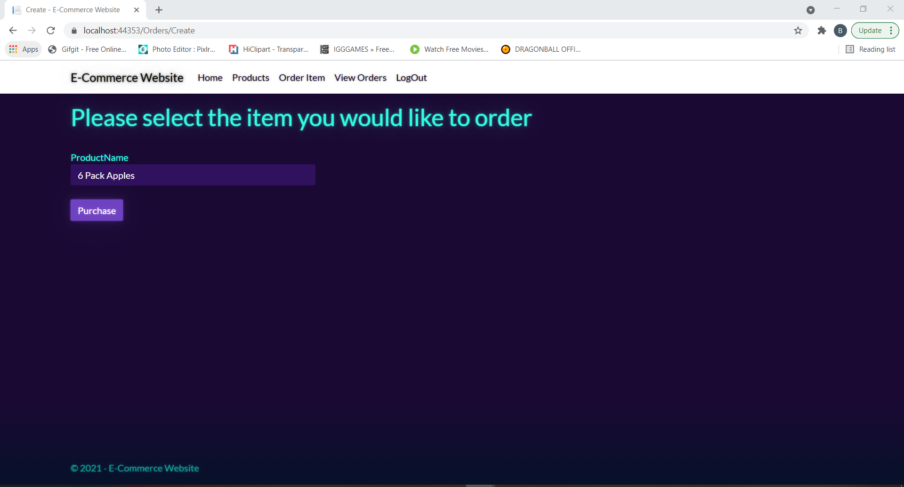

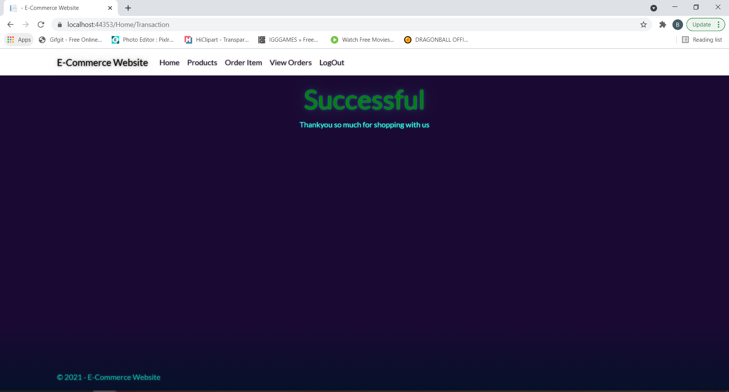

The view orders tab will take the user to a page where they can view their orders and only theirs.

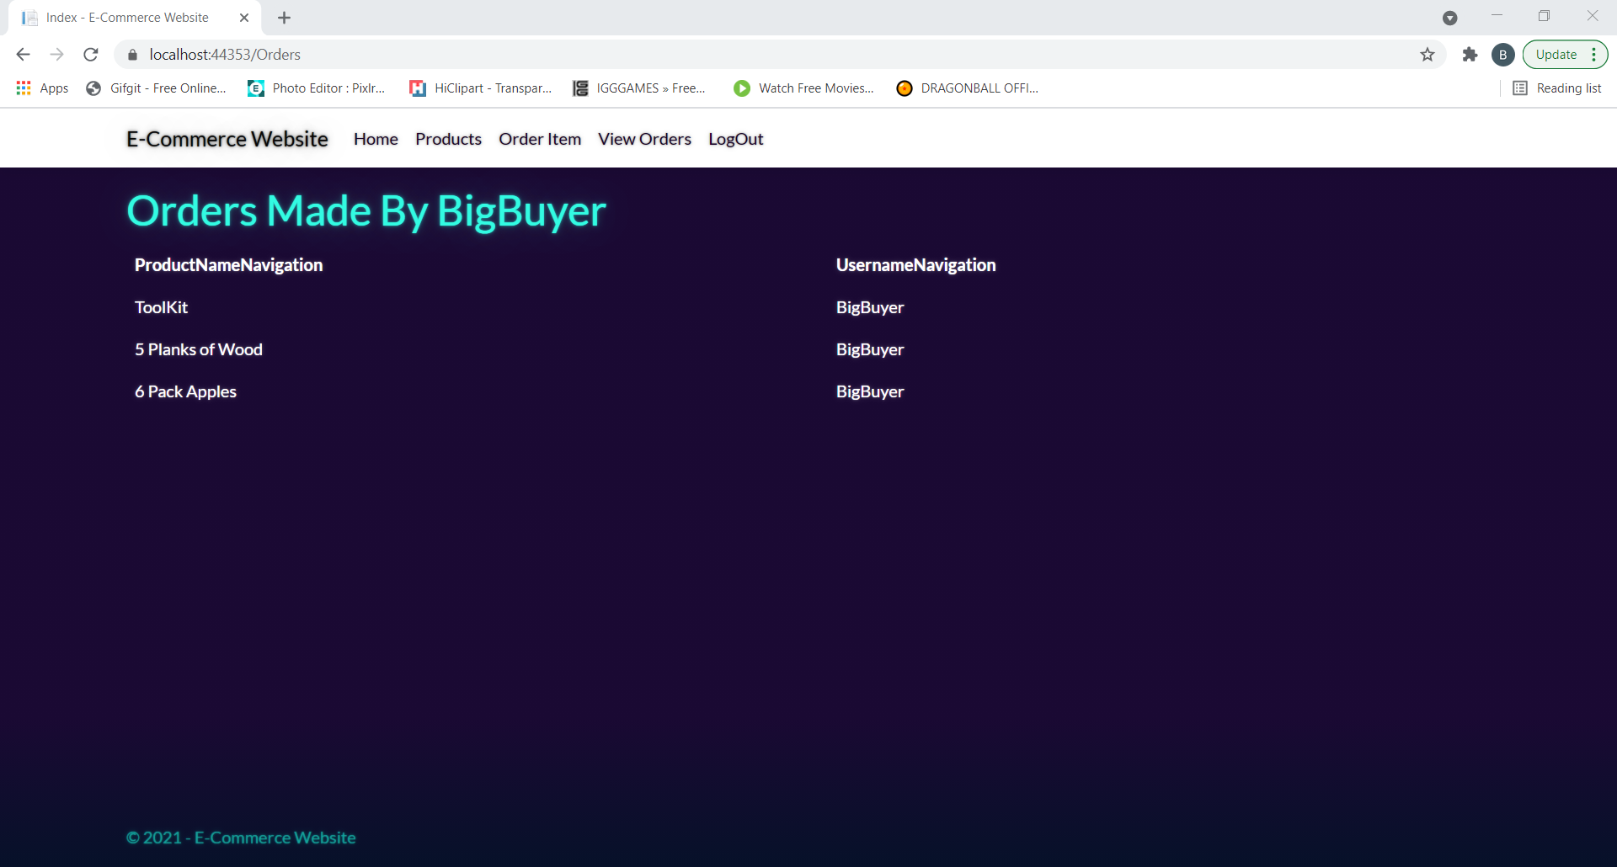

And finally the logout button will take them back to the login page and remove all the tabs in the navbar that people who are not logged in are allowed to use.

**Part 4 Using as an Employee**

For our test emplyee user we have made an account called ‘JonHanmon’ whose password is ‘Yes’. Just like with the customer as soon as you login with an employee you will get the same tabs appearing in the navbar. The main difference for the employee however is that when they click on the view orders tab they will get to see all the orders made instead of filtering out everyones but their own. (Note the only customer made for this test was BigBuyer so for the test we added an order by the employee)

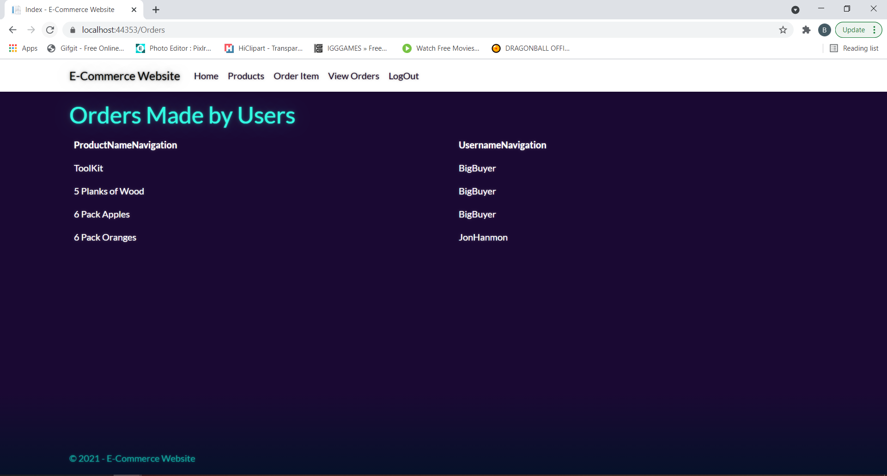

**Part 5 Page Privacy**

If someone tries to access to a page without logging in or don’t have the permissions to be on the page they will be shown one of these two error pages

